Circuits and Switches

Subject:  Related Subjects: | Grade Level(s):  Length of Lesson: | Type: Inquiry / Design / Project  Keywords:

Lesson Overview
Use this section to describe at a high level what the lesson is. Should be no more than 3-4 lines.

Lesson Focus
What is the central question or phenomenon being investigated? What problem are they trying to solve?

Lesson Objective(s) | Students will learn about circuits for the first time and learn what makes up a circuit. After this lesson students should be able to:  - identify the 3 components of a circuit  - know the difference between an open and closed circuit  - learn what switches do and add one to their propeller circuit

Lesson Timing

5 minutes | Introduce the Lesson
30 minutes | ...

Materials | - wires  - wire strippers  - motor  - propeller  - switches (NO, NC, SPST, SPDT)  - battery holders  - batteries (AA)
Instructor Prep | - Step 1
Related Resources | - List related lessons/ppts etc available from USC or outside, trusted orgs

Lesson Plan

Introduction
Circuits power things with electricity. They have at least 3 components: a power source, a power receiver or load, and a conducting path. In the circuits we will be building today, the battery will be the power source, the light or motor will be the power receiver, and the wires will form the conducting path. Circuits can be open (not allowing electricity to flow), or closed (allowing electricity to flow). We will be using switches to open and close the circuits.

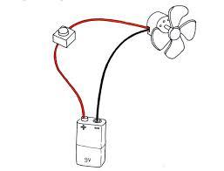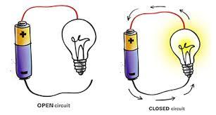

Procedure
- Show students a video about electricity and teach them the components of a circuit
- Give each student a battery holder with wires, a battery, and a light, and have them put the circuit together
- Have students replace the light with a motored propeller
- Have students add a switch to this circuit using another wire
- After putting the entire circuit together and after their propeller works with the switch, we will have them explain to us what each component does and why they put everything together in that way.

Wrap-up
End the lesson with some final discussions about what students designed/discovered. Connect their activity back to the focus question/problem, real world examples, and STEM careers.

Also include notes about any special cleanup considerations

Lesson Background for Teachers

Suggested Real-World STEM Connections
- List possible related Role Models in STEM (with details and links to more reading). Give suggestions for examples of scientists/engineers who are from underrepresented groups in STEM in related careers.
- List related real-world engineering problems and examples

Lesson Variations and Options
Include descriptions of alternative methods or ways to present things.

Explanation
Describe the background concepts and explanations behind the lesson. This can be more in depth than a teacher/instructor would actually share with students.

Key Concepts and Vocabulary
- Word 1: Grade Appropriate Definition
- Word 2: Grade Appropriate Definition

Safety Notes
- Safety instruction

